T-00190919

Piotr Duda

Pong Game.

Rapid Apps Development.

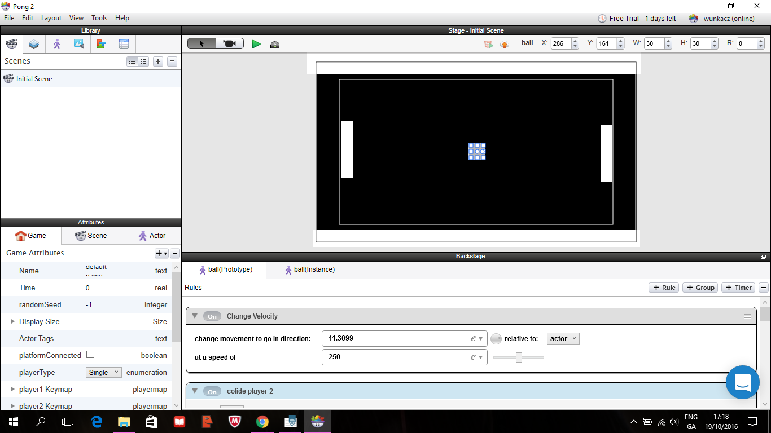Screenshot number 1

This is where I have started creating my Pong Game. The actors are without colour and images. Here I just began to add rules and behaviours to the ball.

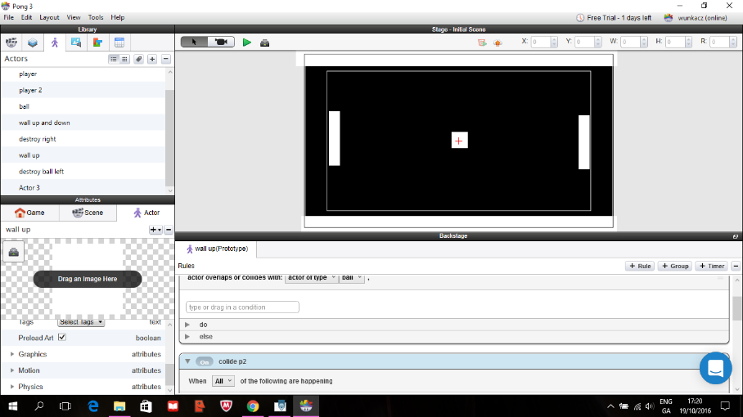

**Screenshot number 3.**

**I have created more actors and added Scene which tells you to PLAY.**

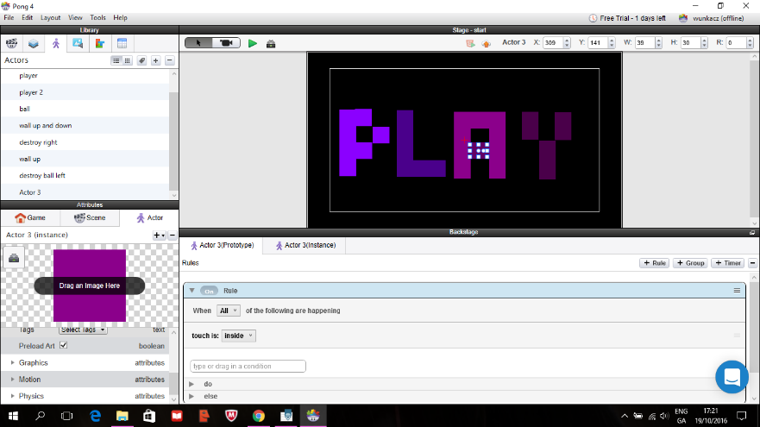When you run the game and press PLAY you will be moved to the Pong Game.

I made the writing with actor and added colour.

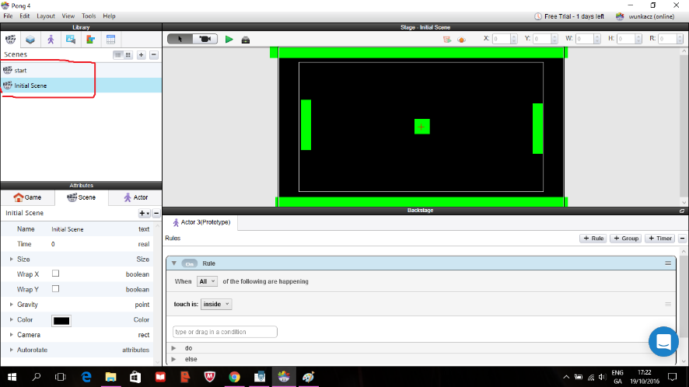

Here I have coloured the actors and the walls as a prototype.

In this screenshot we can see that the background has changed and the ball image was also changed.

The place with red line shows actor that destroys the ball when it collides with the wall. I turned the wall invisible.

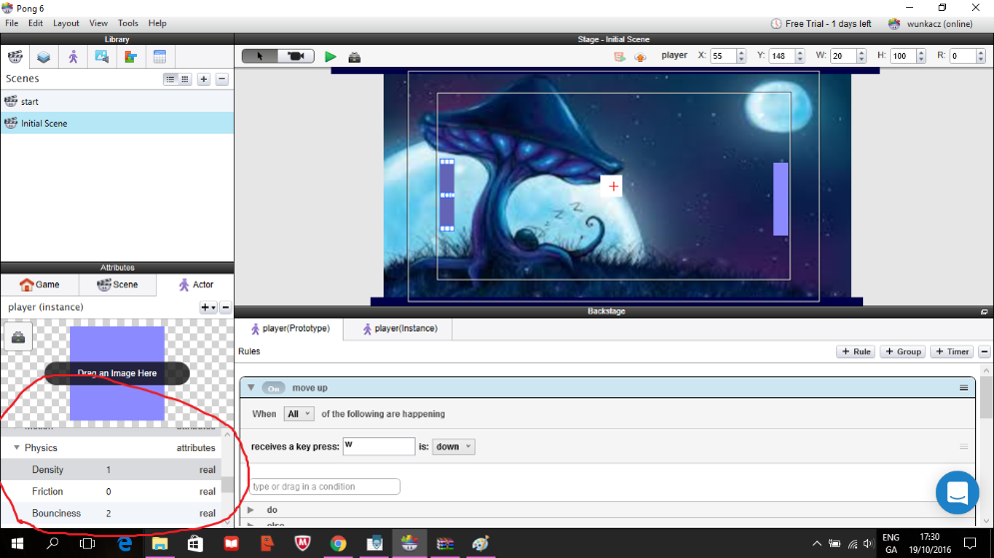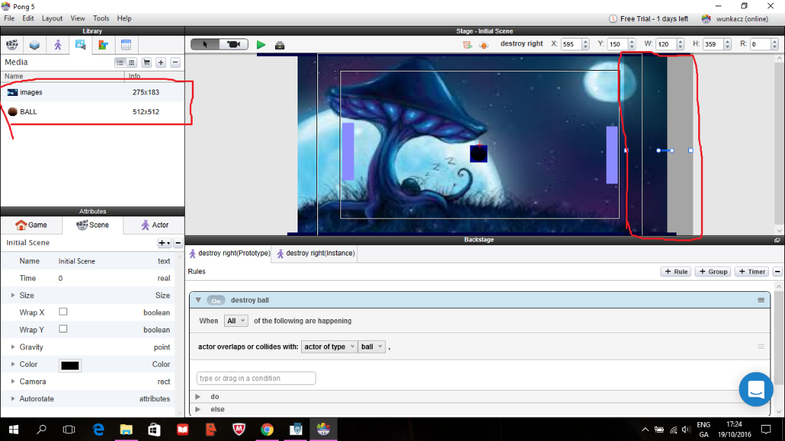

Here I changed the Physics of the actors so when they collide with the ball the ball will bounce and go in the other direction.

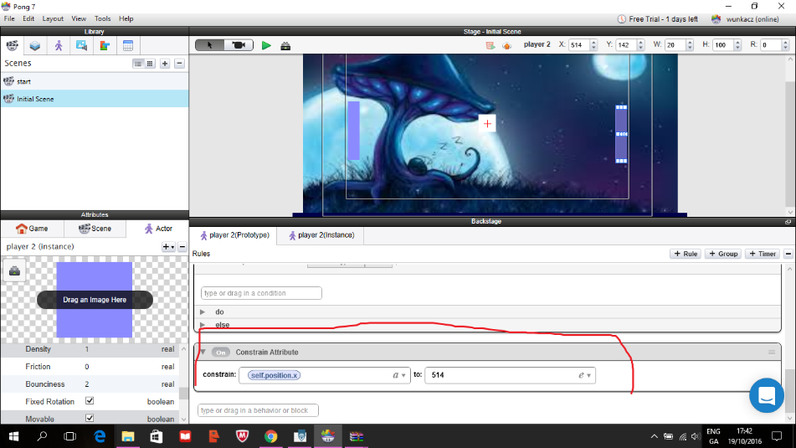Here I changed the right wall attribute so it won’t spin when it hits the ball.

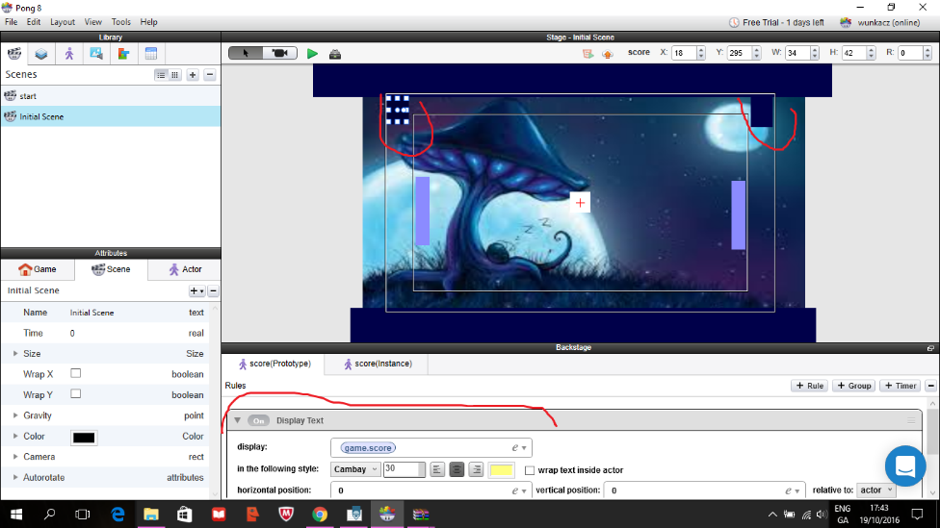I have added Display text here for both players.

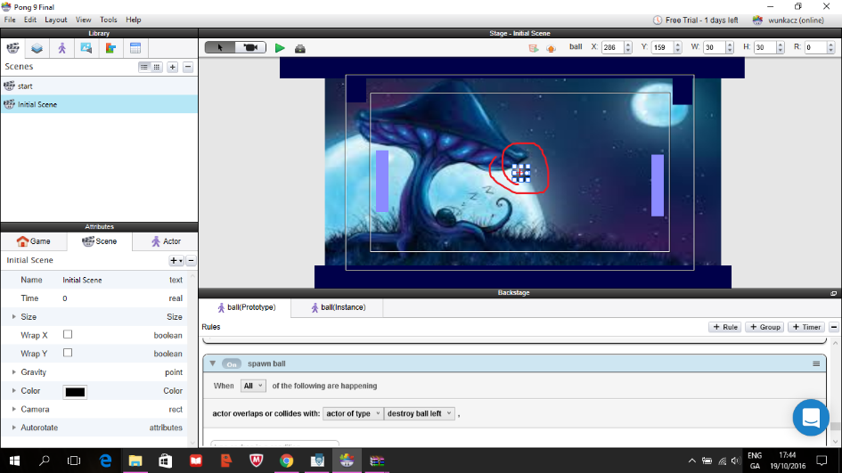

Here I created behaviour to spawn the ball and the music was added at the end.